STIA1123 Programming 2 Group C Exercise

Name: Thong Wei Yong

Matric Number: 279932

Instruction: Create 5 object-oriented example and give their properties and instances.

Class #1: Animals

Instance #2: Crocodile

Properties:

1. Type: Reptiles

2. Dietary: Carnivore

3. Thermoregulation: Cold-blooded

Instance #1: Goat

Properties:

1. Type: Mammals

2. Dietary: Herbivore

3. Thermoregulation: Warm-blooded

Class #1: Animals

Properties:

1. Type

2. Dietary

3. Thermoregulation

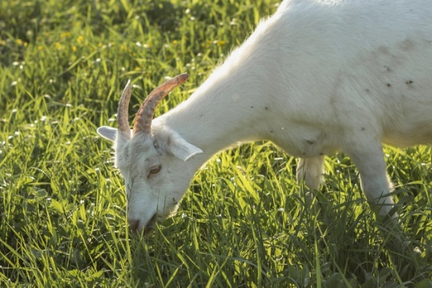 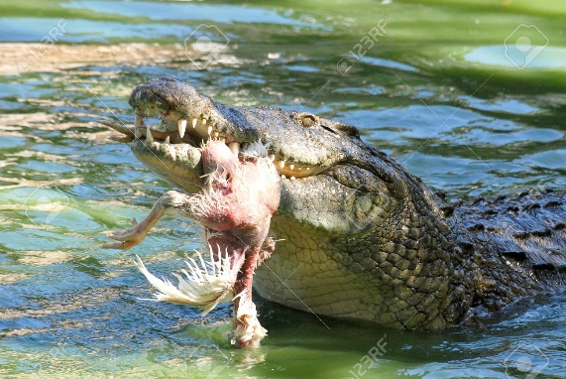

Class #2: Motor vehicles

Instance #2: Motorcycle

Properties:

1. Number of wheels: 2

2. Brands: Honda

3. Color: Black

Instance #1: Car

Properties:

1. Number of wheels: 4

2. Brands: BMW

3. Color: Silver

Class #2: Motor vehicles

Properties:

1. Number of wheels

2. Brands

3. Colors

 

Class #3: Fruits

Class #3: Fruits

Properties:

1. Color

2. Number of seeds:

3. Taste

Instance #2: Lemon

Properties:

1. Color: Green

2. Number of seeds: Many

3. Taste: Sour

Instance #1: Mango

Properties:

1. Color: Yellow

2. Number of seeds: One

3. Taste: Sweet

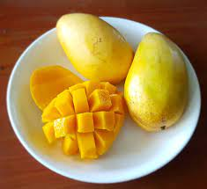 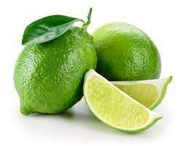Class #4: Person

Instance #1

Properties:

1. Name: Adam

2. Nationality: United States

3. Age: 24

4. Occupation: Software Engineer

Instance #2

Properties:

1. Name: Ali

2. Nationality: Malaysia

3. Age: 20

4. Occupation: University Student

Class #4: Person

Properties:

1. Name

2. Nationality

3. Age

4. Occupation

Class #5: Laptop

Instance #2

Properties:

1. Desktop Brand: Asus

2. CPU Model: AMD Ryzen 4000

3. RAM: 8GB

Instance #1

Properties:

1. Desktop Brand: HP

2. CPU Model: Intel i5

3. RAM: 8GB

Class #5: Desktop

Properties:

1. Desktop Brand

2. CPU Model

3. RAM